**Brain Tumor Classification Using CNN**

**Introduction**

The purpose of this project is to classify brain tumor images into different categories using a Convolutional Neural Network (CNN). Brain tumor classification is an essential task in medical imaging, and this project aims to assist in automating the diagnosis by applying deep learning techniques.

**Dataset**

The dataset used in this project consists of brain tumor images, categorized into classes. The images are resized to 128x128 dimensions for consistency and fed into the CNN model for classification.

Input Dimensions: Images are resized to 128x128 with 3 color channels (RGB).

**Model Architecture**

The CNN model is structured to process image data and extract features for classification. Here's a summary of the architecture used:

1. Convolutional Layers: Extract spatial features from the input images by applying filters.
2. Max Pooling Layers: Downsample the feature maps, reducing the spatial dimensions and computational complexity.
3. Fully Connected (Dense) Layers: Act as a classifier by taking the features and outputting the probability of each class.
4. Activation Functions: ReLU (Rectified Linear Unit) is used for hidden layers, and SoftMax for the output layer.

The model processes the image data and returns a confidence score for each class.

**Data Preprocessing**

The images are preprocessed before being fed into the model:

1. Resizing: All images are resized to 128x128 pixels to ensure uniformity in input dimensions.
2. Normalization: The pixel values of the images are normalized to a range between 0 and 1.

**Training Process**

The model is trained using the processed dataset. During the training phase:

1. Batching: The images are fed in batches to optimize the training process.
2. Optimization Algorithm: An optimizer such as SGD is used to minimize the loss function.
3. Loss Function: Categorical cross-entropy is applied as the loss function due to the multi-class classification nature.

**Model Evaluation**

After training, the model is evaluated on a separate test dataset. The evaluation metrics used include:

1. Accuracy: The ratio of correctly classified images to the total number of images.
2. Confidence Scores: The model outputs a confidence score for each class, which is used to predict the most likely class.

**Results**

The CNN model outputs the classification result with a confidence percentage for each image. For example, after predicting a sample image:

*print(str(res[0][classification] * 100) + "% Confidence This Is A " + names(classification))*

This provides a visual output along with the confidence of the prediction.

**Conclusion**

This project demonstrates the application of CNNs for brain tumor classification. The model can predict whether an image belongs to a specific class of tumors with a high confidence score. The use of CNNs in medical imaging has the potential to improve diagnosis accuracy and speed, assisting healthcare professionals in the decision-making process.

**CNN Model Code –**

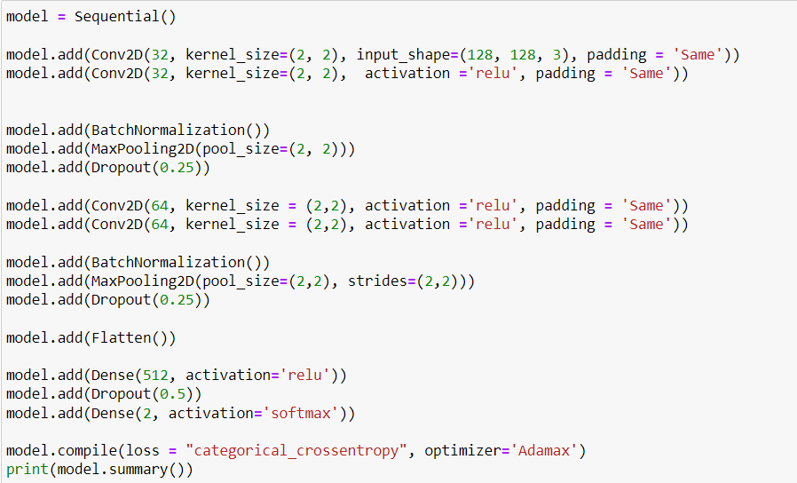

**Epochs 1 to 15 –**

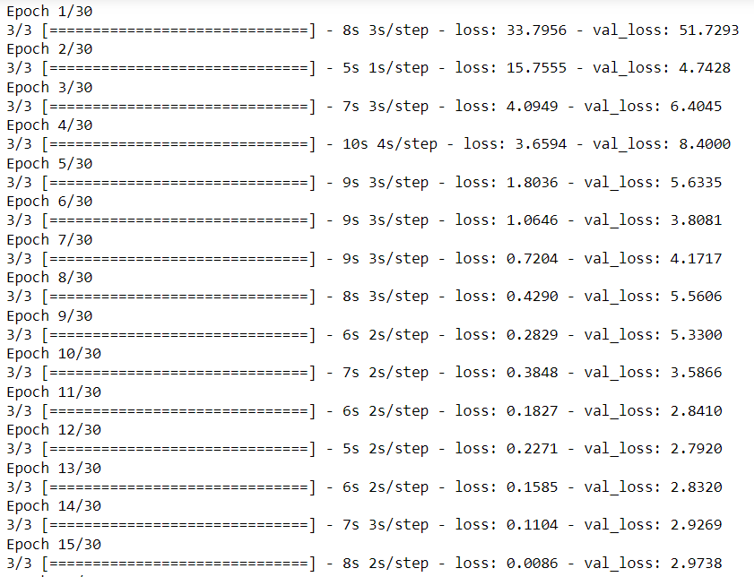

**Evaluating Losses –** 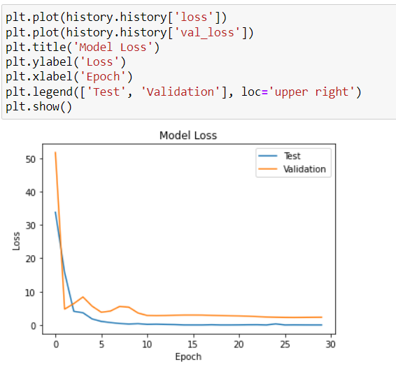

**Code Output –**

